**CANDIDATE MANAGEMENT**

1. **List candidate**
2. Activity diagram

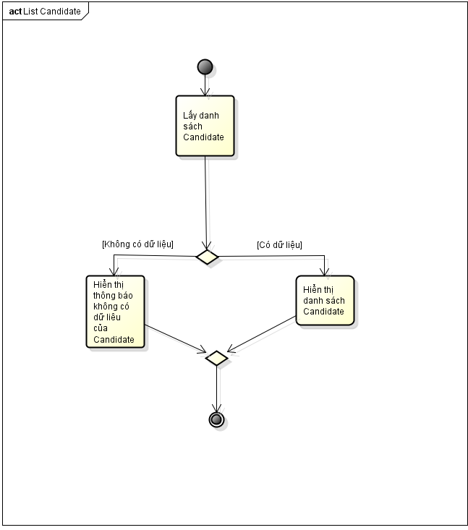

1. Sequence diagram

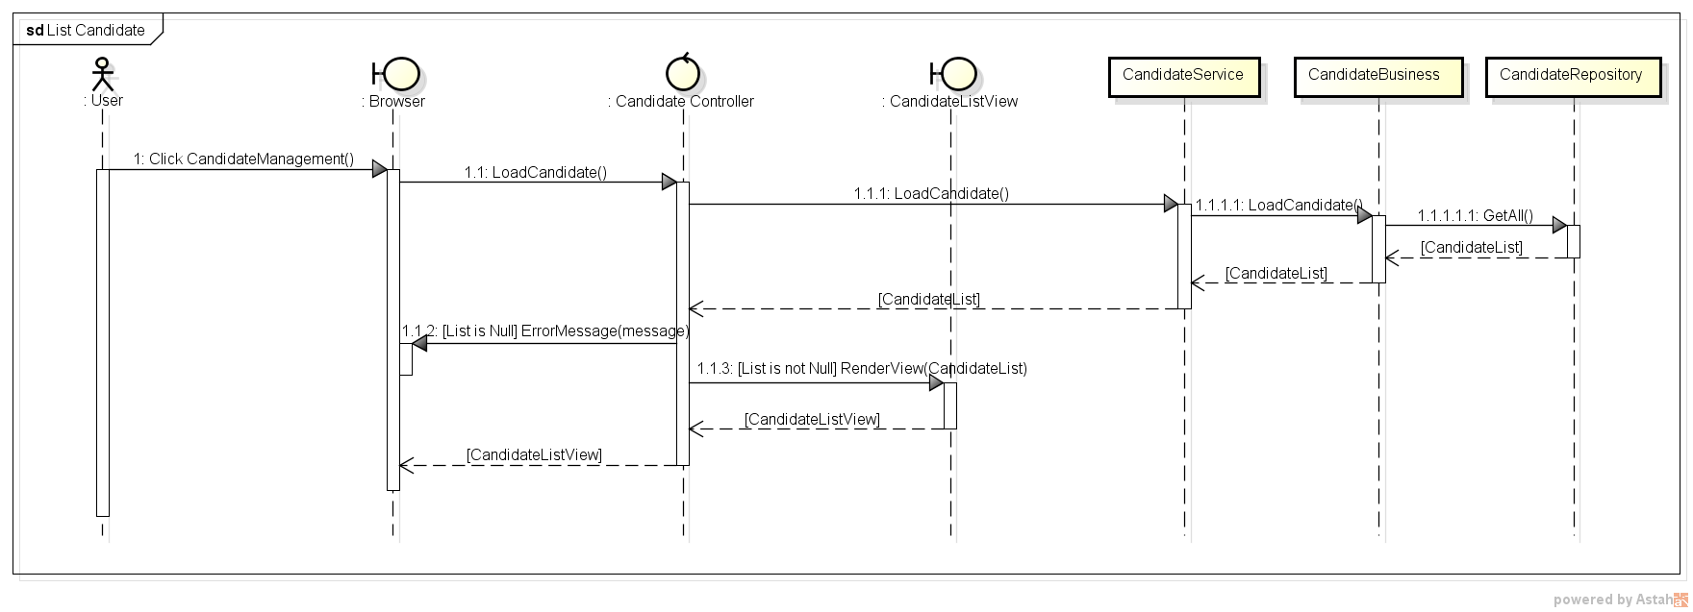

1. **Search candidate**
2. Activity diagram

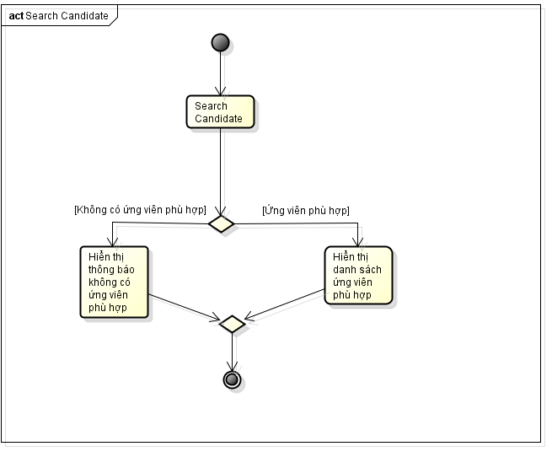

1. Sequence diagram

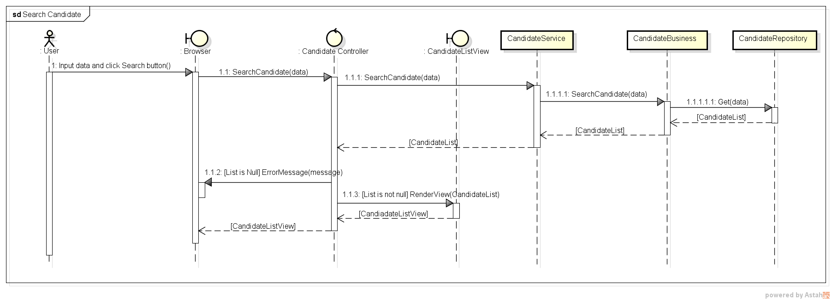

1. **Add candidate**
2. Activity diagram

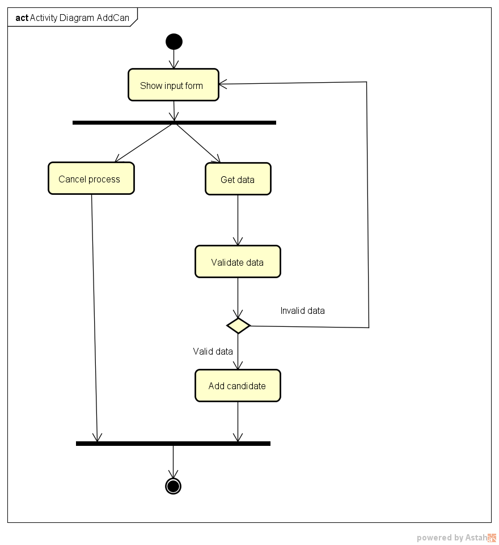

1. Sequence diagram

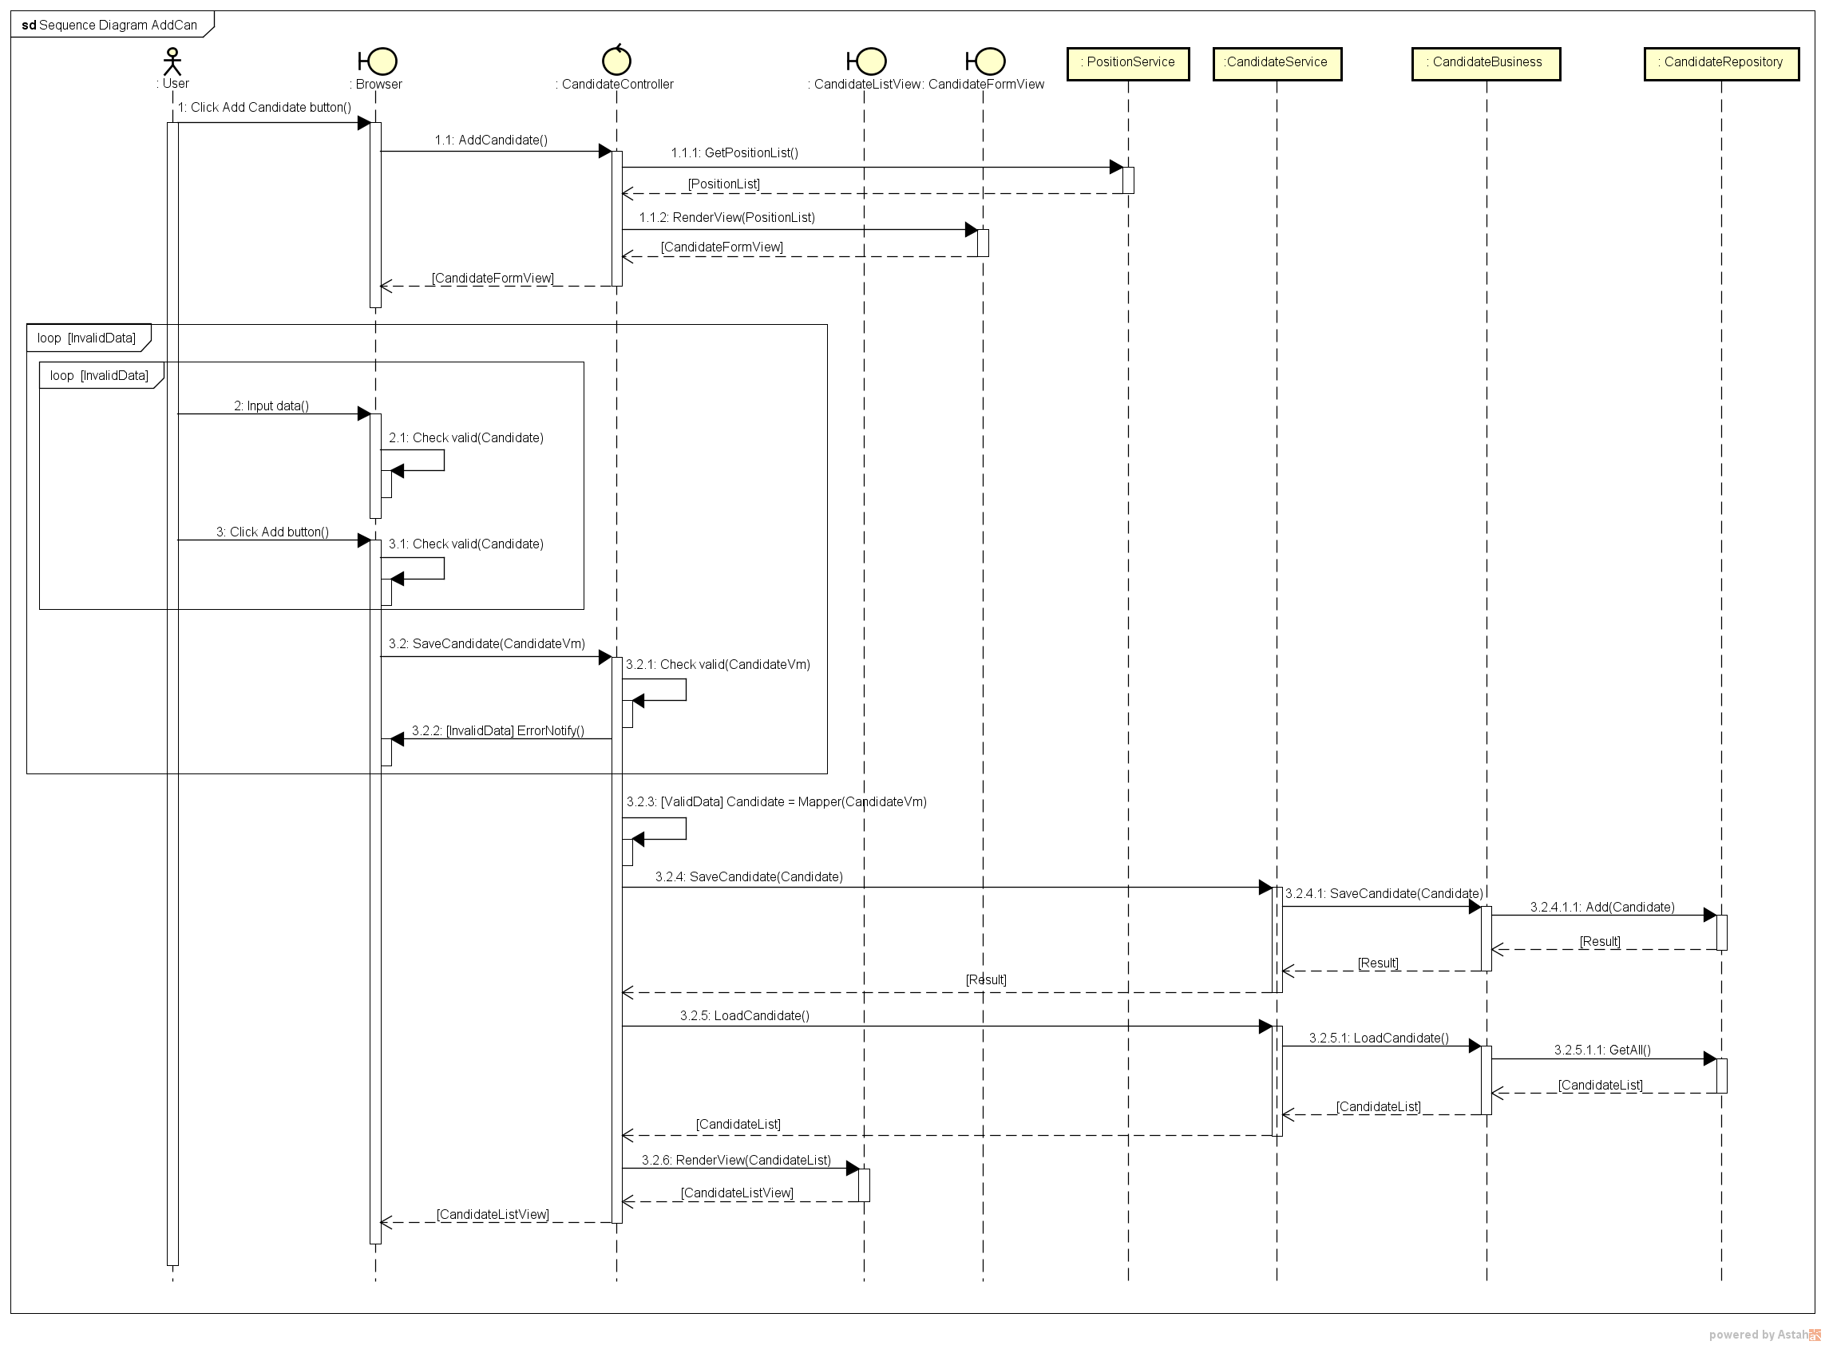

1. **Edit candidate**
2. Activity diagram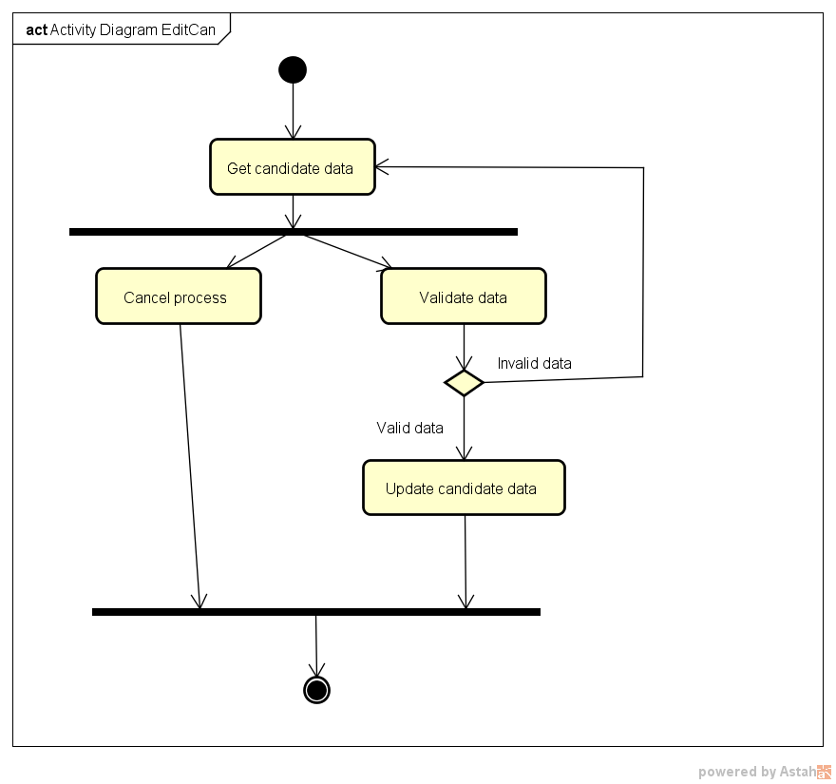
3. Sequence diagram

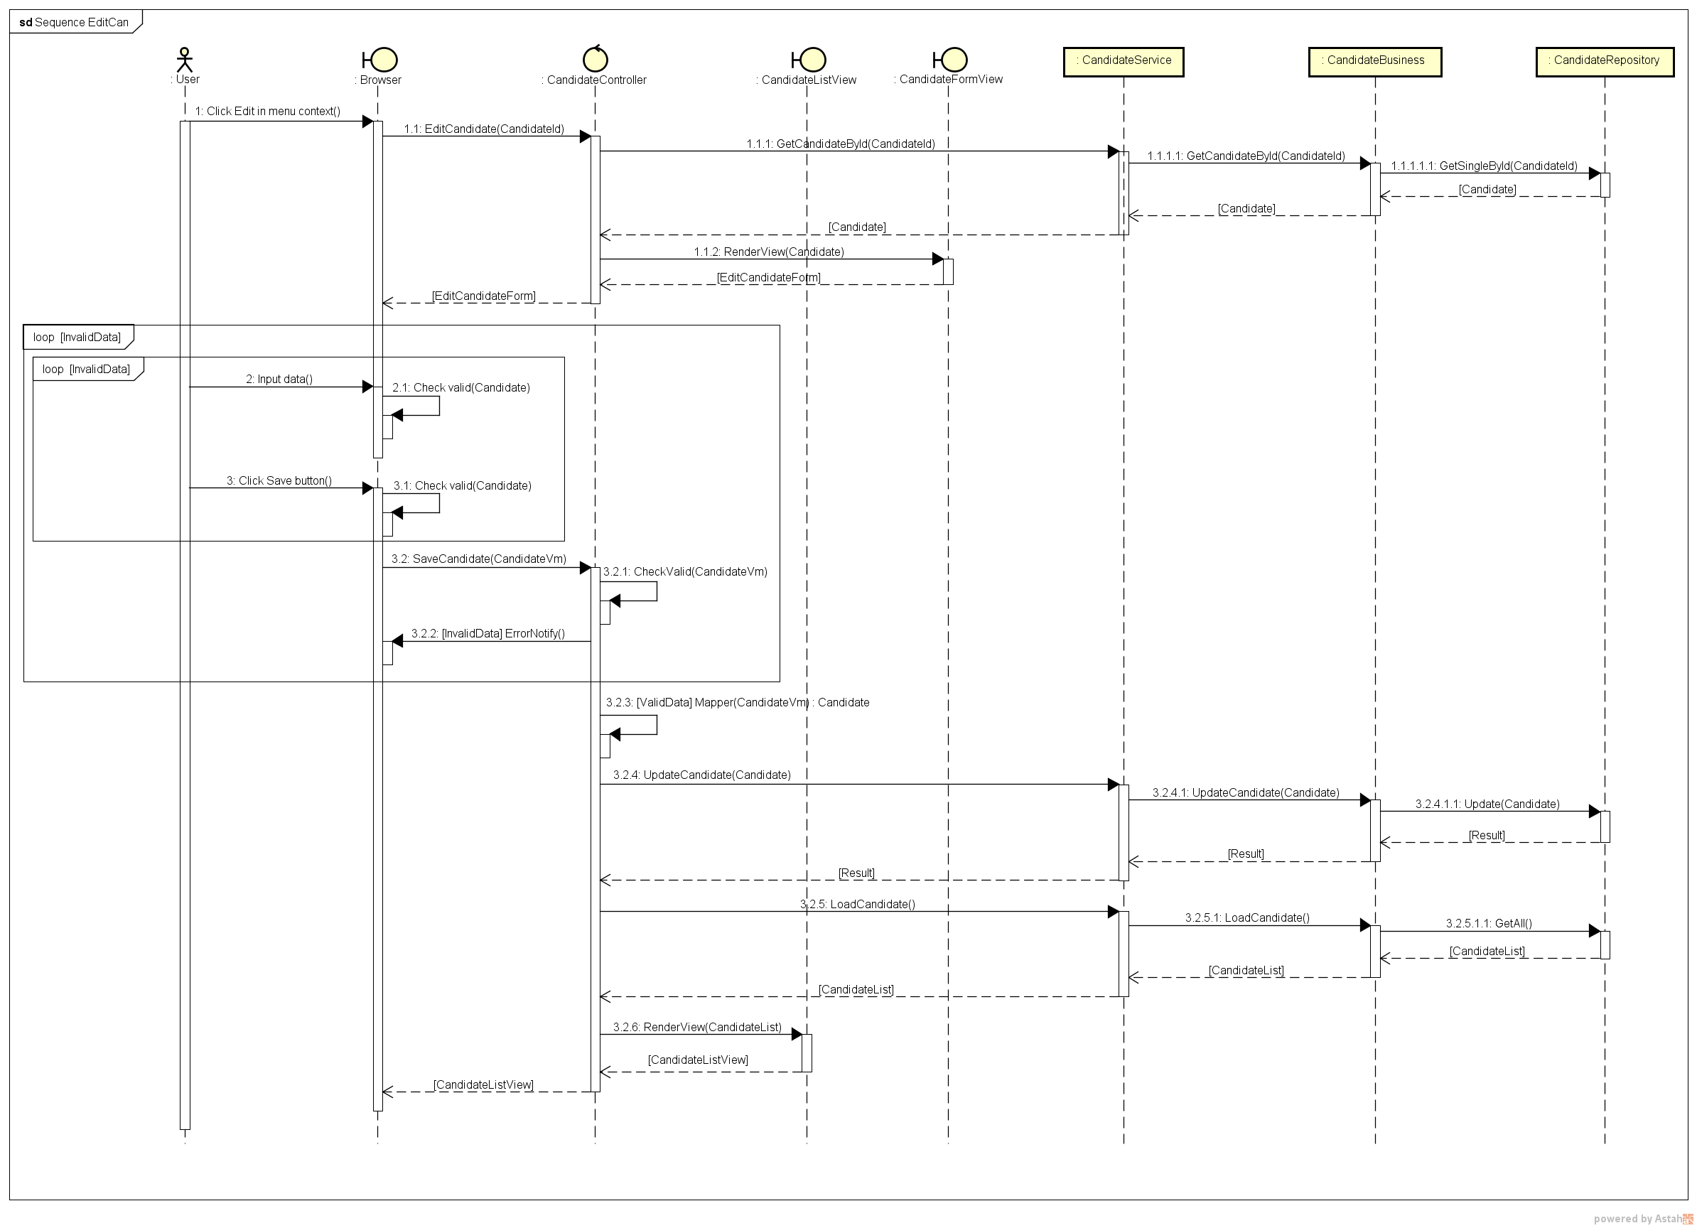

1. **Delete candidate**
2. Activity diagram

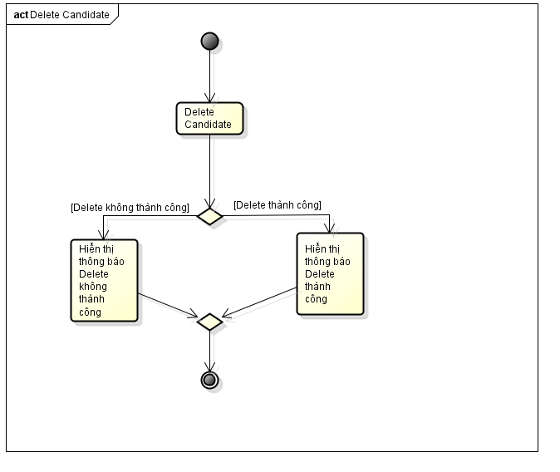

1. Sequence diagram

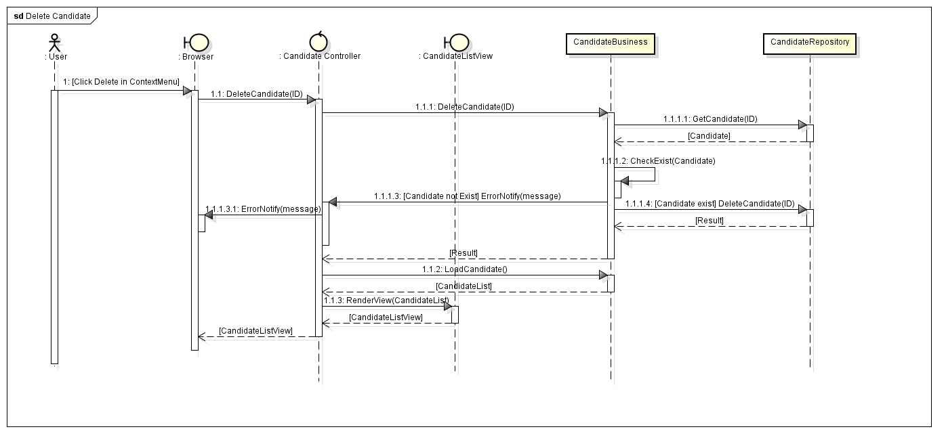

1. **View candidate profile**
2. Activity diagram

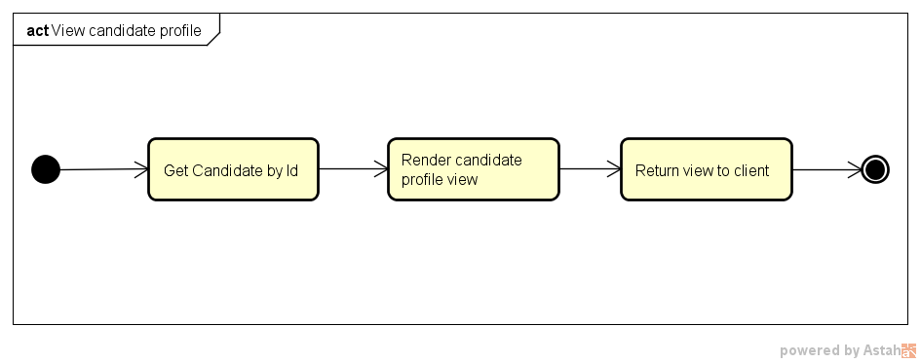

1. Sequence diagram

